Міністерство освіти і науки України  
Національний технічний університет України

«Київський політехнічний інститут»  
Факультет прикладної математики  
Кафедра спеціалізованих комп’ютерних систем

**Лабораторна робота №3**

з дисципліни

«Моделювання»

Виконав:  
 студент групи КВ-93  
Орешко А.В.

Перевірив:

Наливайчук М.В.

_______________

**Київ 2012**

**Постановка задачі**

1. Вивчити теоретичну частину.
2. Ознайомитися з програмою Life в Matlab
3. Вивчити роботу програми Conway's life
4. Для “хаотичної” початкової конфігурації, в якій кожна клітинка знаходиться в стані 1 з ймовірністю 50% розгляньте часову еволюцію правила 00010010 (правила 18), правила 01001001 (правила 73) і правила 10001000 (правила 136).

**Лістинги**

**Rule18:**

clf

clear all

%=============================================

%build the GUI

%define the plot button

plotbutton=uicontrol('style','pushbutton',...

'string','Run', ...

'fontsize',12, ...

'position',[100,400,50,20], ...

'callback', 'run=1;');

%define the stop button

erasebutton=uicontrol('style','pushbutton',...

'string','Stop', ...

'fontsize',12, ...

'position',[200,400,50,20], ...

'callback','freeze=1;');

%define the Quit button

quitbutton=uicontrol('style','pushbutton',...

'string','Quit', ...

'fontsize',12, ...

'position',[300,400,50,20], ...

'callback','stop=1;close;');

number = uicontrol('style','text', ...

'string','1', ...

'fontsize',12, ...

'position',[20,400,50,20]);

n=32;

%initialize the arrays

z = zeros(n,n);

cells = z;

sum = z;

%set a few cells to one

cells(1,1:n) = rand(1,n)<.5;

%how long for each case to stability or simple oscillators

%build an image and display it

imh = image(cat(3,cells,cells,cells));

set(imh, 'erasemode', 'none')

axis equal

axis tight

%index definition for cell update

x = 2:n;

y = 2:n;

%Main event loop

stop= 0; %wait for a quit button push

run = 0; %wait for a draw

freeze = 0; %wait for a freeze

stepnumber = str2num(get(number,'string'));

while (stepnumber<993)

if (run==1)

for x=2:n

%nearest neighbor sum

sum(x,1) = cells(x-1, 2) + cells(x-1,n) ;

cells(x,1) = (sum(x,1)==1) & (cells(1,1)==0);

set(imh, 'cdata', cat(3,cells,cells,cells) )

%update the step number diaplay

stepnumber = 1 + str2num(get(number,'string'));

set(number,'string',num2str(stepnumber));

for y=2:(n-1)

sum(x,y) = cells(x-1, y-1) + cells(x-1,y+1) ;

% The CA rule

cells(x,y) = (sum(x,y)==1) & (cells(x-1,y)==0);

%draw the new image

set(imh, 'cdata', cat(3,cells,cells,cells) )

%update the step number diaplay

stepnumber = 1 + str2num(get(number,'string'));

set(number,'string',num2str(stepnumber))

end

sum(x,n) = cells(x-1, n-1) + cells(x-1,1) ;

cells(x,n) = (sum(x,n)==1) & (cells(1,n)==0);

set(imh, 'cdata', cat(3,cells,cells,cells) )

%update the step number diaplay

stepnumber = 1 + str2num(get(number,'string'));

set(number,'string',num2str(stepnumber));

end

end

if (freeze==1)

run = 0;

freeze = 0;

end

drawnow %need this in the loop for controls to work

end

**Rule73:**

clf

clear all

%=============================================

%build the GUI

%define the plot button

plotbutton=uicontrol('style','pushbutton',...

'string','Run', ...

'fontsize',12, ...

'position',[100,400,50,20], ...

'callback', 'run=1;');

%define the stop button

erasebutton=uicontrol('style','pushbutton',...

'string','Stop', ...

'fontsize',12, ...

'position',[200,400,50,20], ...

'callback','freeze=1;');

%define the Quit button

quitbutton=uicontrol('style','pushbutton',...

'string','Quit', ...

'fontsize',12, ...

'position',[300,400,50,20], ...

'callback','stop=1;close;');

number = uicontrol('style','text', ...

'string','1', ...

'fontsize',12, ...

'position',[20,400,50,20]);

%=============================================

%CA setup

n=32;

%initialize the arrays

z = zeros(n,n);

cells = z;

sum = z;

%set a few cells to one

cells(1,1:n) = rand(1,n)<.5;

%how long for each case to stability or simple oscillators

%build an image and display it

imh = image(cat(3,cells,cells,cells));

set(imh, 'erasemode', 'none')

axis equal

axis tight

%index definition for cell update

x = 2:n;

y = 2:n;

%Main event loop

stop= 0; %wait for a quit button push

run = 0; %wait for a draw

freeze = 0; %wait for a freeze

stepnumber = str2num(get(number,'string'));

while (stepnumber<993)

if (run==1)

for x=2:n

%nearest neighbor sum

sum(x,1) = cells(x-1, 2) + cells(x-1,n) ;

cells(x,1) = ((sum(x,1)==1) & (cells(1,1)==1)) | ((sum(x,1)==0) & (cells(1,1)==0));

set(imh, 'cdata', cat(3,cells,cells,cells) )

%update the step number diaplay

stepnumber = 1 + str2num(get(number,'string'));

set(number,'string',num2str(stepnumber));

for y=2:(n-1)

sum(x,y) = cells(x-1, y-1) + cells(x-1,y+1) ;

% The CA rule

cells(x,y) = ((sum(x,y)==1) & (cells(x-1,y)==1)) | ((sum(x,y)==0) & (cells(x-1,y)==0));

%draw the new image

set(imh, 'cdata', cat(3,cells,cells,cells) )

%update the step number diaplay

stepnumber = 1 + str2num(get(number,'string'));

set(number,'string',num2str(stepnumber))

end

sum(x,n) = cells(x-1, n-1) + cells(x-1,1) ;

cells(x,n) = ((sum(x,n)==1) & (cells(1,n)==1)) | ((sum(x,n)==0) & (cells(1,n)==0));

set(imh, 'cdata', cat(3,cells,cells,cells) )

%update the step number diaplay

stepnumber = 1 + str2num(get(number,'string'));

set(number,'string',num2str(stepnumber));

end

end

if (freeze==1)

run = 0;

freeze = 0;

end

drawnow %need this in the loop for controls to work

end

**Rule136:**

clf

clear all

%=============================================

%build the GUI

%define the plot button

plotbutton=uicontrol('style','pushbutton',...

'string','Run', ...

'fontsize',12, ...

'position',[100,400,50,20], ...

'callback', 'run=1;');

%define the stop button

erasebutton=uicontrol('style','pushbutton',...

'string','Stop', ...

'fontsize',12, ...

'position',[200,400,50,20], ...

'callback','freeze=1;');

%define the Quit button

quitbutton=uicontrol('style','pushbutton',...

'string','Quit', ...

'fontsize',12, ...

'position',[300,400,50,20], ...

'callback','stop=1;close;');

number = uicontrol('style','text', ...

'string','1', ...

'fontsize',12, ...

'position',[20,400,50,20]);

%=============================================

%CA setup

n=32;

%initialize the arrays

z = zeros(n,n);

cells = z;

sum = z;

%set a few cells to one

cells(1,1:n) = rand(1,n)<.5;

%how long for each case to stability or simple oscillators

%build an image and display it

imh = image(cat(3,cells,cells,cells));

set(imh, 'erasemode', 'none')

axis equal

axis tight

%index definition for cell update

x = 2:n;

y = 2:n;

%Main event loop

stop= 0; %wait for a quit button push

run = 0; %wait for a draw

freeze = 0; %wait for a freeze

stepnumber = str2num(get(number,'string'));

while (stepnumber<993)

if (run==1)

for x=2:n

%nearest neighbor sum

for y=1:(n-1)

sum(x,y) = cells(x-1, y) + cells(x-1,y+1) ;

% The CA rule

cells(x,y) = (sum(x,y)==2);

%draw the new image

set(imh, 'cdata', cat(3,cells,cells,cells) )

%update the step number diaplay

stepnumber = 1 + str2num(get(number,'string'));

set(number,'string',num2str(stepnumber))

end

sum(x,n) = cells(x-1, n) + cells(x-1,1) ;

cells(x,n) = (sum(x,n)==2);

set(imh, 'cdata', cat(3,cells,cells,cells) )

%update the step number diaplay

stepnumber = 1 + str2num(get(number,'string'));

set(number,'string',num2str(stepnumber));

end

end

if (freeze==1)

run = 0;

freeze = 0;

end

drawnow %need this in the loop for controls to work

end

***результати:***

**Rule18:**

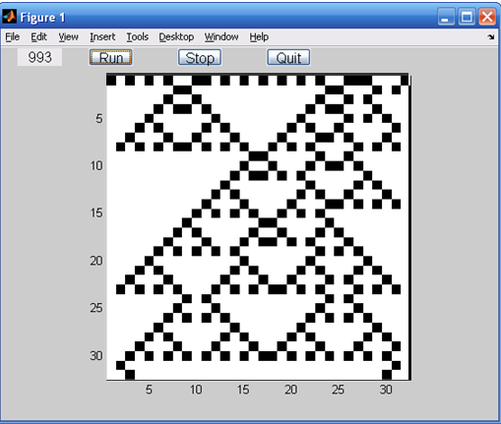

**Rule73:**

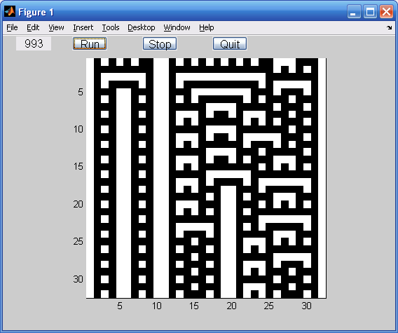

**Rule136:**

